**Call Center Al Mundo**

**Arquitectura**

Dado los requerimientos realizó la prueba de backend utilizando Maven para la gestión de dependencias, Java en su versión 8 para el desarrollo de la lógica y JUnit para las pruebas unitarias.

* **Diagrama de Clases**

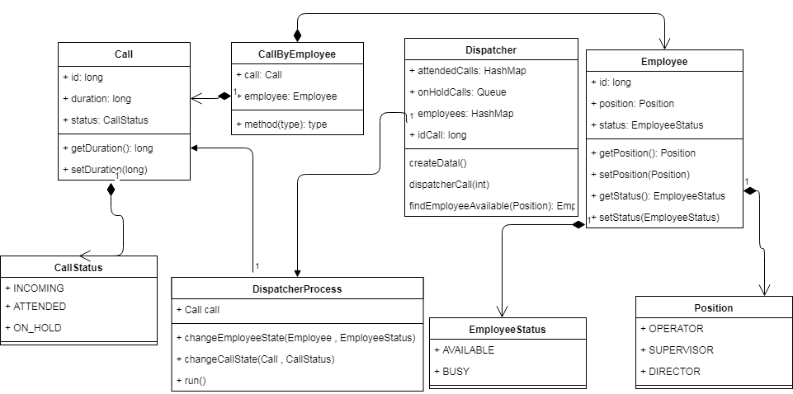

* **Implementación de las Clases**

Clases constructoras con objetos de negocio (bo – Business Object): los cuales son utilizados como representaciones de las entidades que se utilizan para almacenar la data del negocio, Call representación de la llamada, Employee representación del empleado que toma la llamada, adicionalmente se crea un objeto de negocio llamado CallByEmployee el cual es un objeto intermedio que se encarga de almacenar la llamada cuando es asignada al empleado. Estos objetos de negocio hacen uso de las Enumeraciones que contienen los estados y el cargo de los empleados.

Call -> Estados (INCOMING, ATTENDED, ON_HOLD) – Employee -> Estados (AVAILABLE, BUSY) -> Cargos (OPERATOR, SUPERVISOR, DIRECTOR).

Las clases de tipo servicio de negocio (bs – Business Service) se encargan de crear objetos basados en las clases (bo), y realizar la manipulación de estos para cumplir con los requerimientos solicitados. DispatcherProcess es la clase tipo (bs) y dentro de esta ocurre la lógica de una llamada que es atendida o encolada para luego ser atendida, esta clase implementa la interfaz Runnable la cual es una forma para implementar Threads en un proyecto JAVA, dentro del método que se sobreescribe (run), se realiza la lógica con la llamada en el momento que es asignada, tomada por el empleado y finalizada, para esto se está usando un HashMap de llamadas atendidas (attendedCalls).

Finalmente, la clase Maestro Dispatcher, contiene las estructuras de datos que se van a utilizar a lo largo de la aplicación y en donde se va a almacenar los datos necesarios para la finalización de los procesos, esta clase tiene sus objetos de tipo static los cuales será manipulados a lo largo de la ejecución del proceso de atención a una llamada.

* **Descripción de clases**

Clase Employee: contiene los datos del empleado, como id, estado (status) y cargo (Position)

Clase Call: contiene los datos de la llamada, como di, estado (status)

Clase CallByEmployee: contiene los datos de una llamada asignada a un empleado, (Employee), (Call)

Enumeración Position: contiene los tres cargos posibles OPERATOR, SUPERVISOR, DIRECTOR

Enumeración EmployeeStatus: contiene los estados de un empleado tales como AVAILABLE, BUSY

Enumeración CallStatus: contiene los estados de una llamada tales como INCOMING, ATTENDED, ON_HOLD, este último estado se creó para manejar las llamadas que sobre pasa el límite de concurrencia

Clase Constants: contiene las constantes que se utilizan a lo largo de la aplicación

Clase DispatcherProcess: contiene la clase que se encarga de definir el proceso de una llamada cuando es creada, cuando se hace una instanciación de esta clase se envía un parámetro a su método constructor, este parámetro de tipo booleano define si se crea una nueva llamada o solo es la ejecución de una llamada en espera, contiene los métodos changeCallStatus que se encarga de modificar el estado de una llamada y el método changeEmployeeStatus, el cua se encarga de modificar el estado de un empleado, la lógica fuerte del proceso de atención de una llamada ocurre en el método run el cual sobreescribe la implementación de la clase Runnable.

Clase Dispatcher: contiene las estructura de datos que será utilizadas por la clase DispatcherProcess, esta clase contiene el método DispatchCall la cual realiza la instanciación de la clase DispatcherProcess, lo cual significa el momento en el que entra una llamada y el proceso que esta toma, se utiliza un objeto de tipo ExecutorService el cual permite definir la cantidad de hilos que estará corriendo de forma simultánea, el método createData se encarga de crear la data para los empleados, se crean 6 de tipo OPERATOR, 3 de tipo SUPERVISOR y finalmente un único DIRECTOR, el método findAvailableEmployee se encarga de buscar un empleado teniendo como criterio el cargo recibido como parámetro, finalmente retorna este valor al DispatcherProcess para que este ejecute su labor de asignación.

La clase App es la clase principal donde inicial la ejecución.

* **Pruebas unitarias**

Se realizaron pruebas unitarias de las clases constructoras, se probaron que sus constructores funcionaran, también se incluyeron pruebas unitarias en los servicios de negocio, validando que el proceso se esté cumpliendo y finalmente la clase Dispatcher donde se prueba la creación de los datos y las estructuras que contendrán la data.

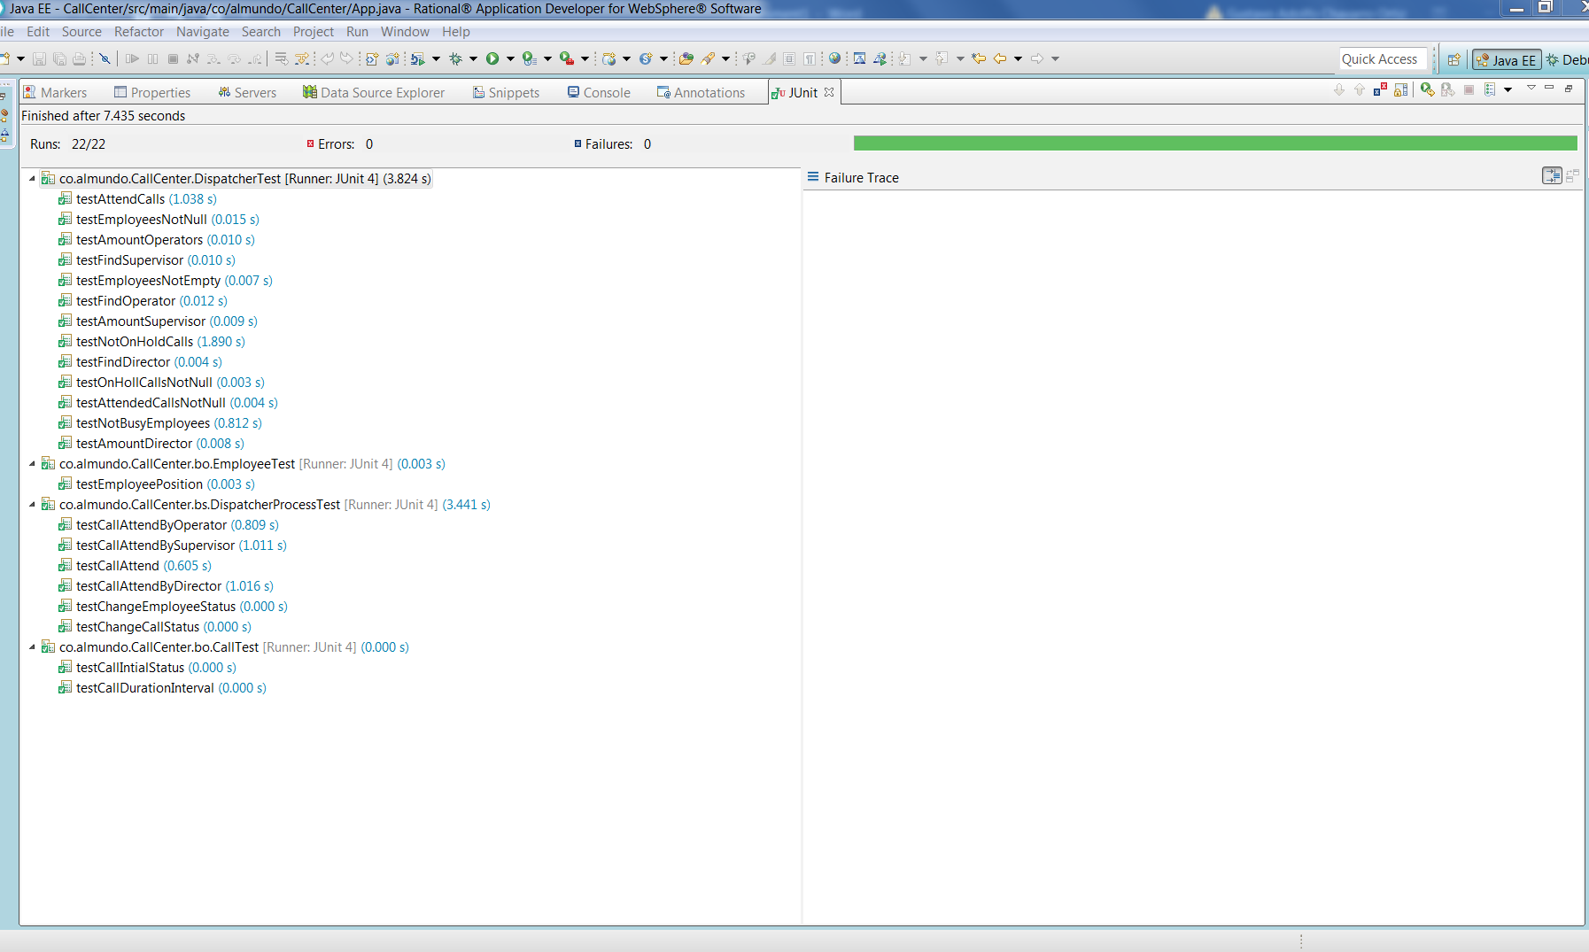

* **Cubrimiento de las pruebas**

Las pruebas contienen un cubrimiento del 89.6% lo cual indica que es un cubrimiento de la mayor parte del proyecto, el 10.4% faltante obedece al no cubrimiento de los paquetes donde se encuentran las Enumeraciones, esto puede obviarse del proyecto colocando las enumeraciones como excluidas del cubrimiento.

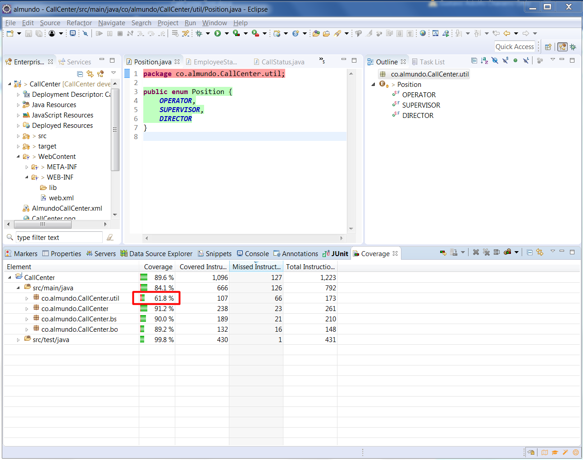

* **Descripción del proceso**

Para la definición del proceso se utilizará el log generado por la aplicación en una ejecución con 30 llamadas.

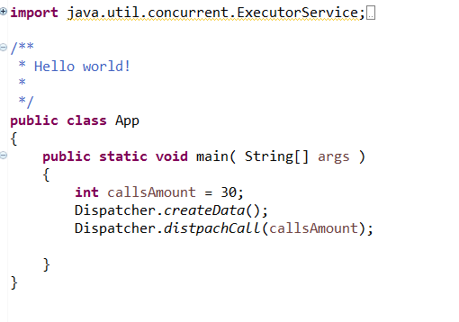

Una vez se ejecuta el método main() se obtiene el siguiente log de la aplicación:

Nota: en comentarios color negro se explica cada sección.

Se invoca el método createData

2018-03-11 23:19:17 INFO Dispatcher:35 - Creating an Employee N°: 1 with position: OPERATOR

2018-03-11 23:19:17 INFO Dispatcher:35 - Creating an Employee N°: 2 with position: OPERATOR

2018-03-11 23:19:17 INFO Dispatcher:35 - Creating an Employee N°: 3 with position: OPERATOR

2018-03-11 23:19:17 INFO Dispatcher:35 - Creating an Employee N°: 4 with position: OPERATOR

2018-03-11 23:19:17 INFO Dispatcher:35 - Creating an Employee N°: 5 with position: OPERATOR

2018-03-11 23:19:17 INFO Dispatcher:35 - Creating an Employee N°: 6 with position: OPERATOR

2018-03-11 23:19:17 INFO Dispatcher:39 - Creating an Employee N°: 7 with position: SUPERVISOR

2018-03-11 23:19:17 INFO Dispatcher:39 - Creating an Employee N°: 8 with position: SUPERVISOR

2018-03-11 23:19:17 INFO Dispatcher:39 - Creating an Employee N°: 9 with position: SUPERVISOR

2018-03-11 23:19:17 INFO Dispatcher:44 - Creating an Employee N°: 10 with position: DIRECTOR

Se realiza la ejecución de los 10 hilos para las primeras llamadas se busca un empleado disponible

2018-03-11 23:19:17 DEBUG DispatcherProcess:30 - finding a employee available

2018-03-11 23:19:17 DEBUG DispatcherProcess:30 - finding a employee available

2018-03-11 23:19:17 DEBUG DispatcherProcess:30 - finding a employee available

2018-03-11 23:19:17 DEBUG DispatcherProcess:30 - finding a employee available

2018-03-11 23:19:17 DEBUG DispatcherProcess:30 - finding a employee available

2018-03-11 23:19:17 DEBUG DispatcherProcess:30 - finding a employee available

2018-03-11 23:19:17 DEBUG DispatcherProcess:30 - finding a employee available

2018-03-11 23:19:17 DEBUG DispatcherProcess:30 - finding a employee available

2018-03-11 23:19:17 DEBUG DispatcherProcess:30 - finding a employee available

2018-03-11 23:19:17 DEBUG DispatcherProcess:30 - finding a employee available

Se encuentra el primer empleado de tipo OPERATOR, y se toma la llamada y se muestran los empleados disponibles

2018-03-11 23:19:17 INFO Dispatcher:95 - found Employee ID: 1 position: OPERATOR employees availables: 9

Se muestran las llamadas entrantes que restan por atender

2018-03-11 23:19:17 INFO DispatcherProcess:41 - Calls incoming: 29

Se muestra la llamada N° cuanto tiene de duración y el empleado que la atendió

2018-03-11 23:19:17 INFO DispatcherProcess:45 - The call N°1 begins with 6 seconds and the employee N° 1 and Position: OPERATOR

Se muestra la cantidad de llamadas atendidas

2018-03-11 23:19:17 INFO DispatcherProcess:47 - Calls attended 1

Sucede para la llamada 2 lo mismo explicado anteriormente

2018-03-11 23:19:17 INFO Dispatcher:95 - found Employee ID: 2 position: OPERATOR employees availables: 8

2018-03-11 23:19:17 INFO DispatcherProcess:41 - Calls incoming: 28

2018-03-11 23:19:17 INFO DispatcherProcess:45 - The call N°2 begins with 6 seconds and the employee N° 2 and Position: OPERATOR

2018-03-11 23:19:17 INFO DispatcherProcess:47 - Calls attended 2

2018-03-11 23:19:17 INFO Dispatcher:95 - found Employee ID: 3 position: OPERATOR employees availables: 7

2018-03-11 23:19:17 INFO DispatcherProcess:41 - Calls incoming: 27

2018-03-11 23:19:17 INFO DispatcherProcess:45 - The call N°3 begins with 9 seconds and the employee N° 3 and Position: OPERATOR

2018-03-11 23:19:17 INFO DispatcherProcess:47 - Calls attended 3

2018-03-11 23:19:17 INFO Dispatcher:95 - found Employee ID: 4 position: OPERATOR employees availables: 6

2018-03-11 23:19:17 INFO DispatcherProcess:41 - Calls incoming: 26

2018-03-11 23:19:17 INFO Dispatcher:95 - found Employee ID: 5 position: OPERATOR employees availables: 5

2018-03-11 23:19:17 INFO DispatcherProcess:45 - The call N°4 begins with 7 seconds and the employee N° 4 and Position: OPERATOR

2018-03-11 23:19:17 INFO DispatcherProcess:47 - Calls attended 4

2018-03-11 23:19:17 INFO Dispatcher:95 - found Employee ID: 6 position: OPERATOR employees availables: 4

2018-03-11 23:19:17 INFO DispatcherProcess:41 - Calls incoming: 25

2018-03-11 23:19:17 INFO DispatcherProcess:33 - At this time there are not OPERATOR available, it will be attended by a SUPERVISOR

2018-03-11 23:19:17 INFO DispatcherProcess:41 - Calls incoming: 24

2018-03-11 23:19:17 INFO DispatcherProcess:33 - At this time there are not OPERATOR available, it will be attended by a SUPERVISOR

2018-03-11 23:19:17 INFO DispatcherProcess:45 - The call N°6 begins with 7 seconds and the employee N° 6 and Position: OPERATOR

Se muestra que ya no hay OPERATORS disponibles y que será atendido por un SUPERVISOR

2018-03-11 23:19:17 INFO DispatcherProcess:33 - At this time there are not OPERATOR available, it will be attended by a SUPERVISOR

2018-03-11 23:19:17 INFO DispatcherProcess:47 - Calls attended 6

Se muestra que fue encontrado un SUPERVISOR disponbile

2018-03-11 23:19:17 INFO Dispatcher:95 - found Employee ID: 7 position: SUPERVISOR employees availables: 3

2018-03-11 23:19:17 INFO DispatcherProcess:41 - Calls incoming: 23

2018-03-11 23:19:17 INFO DispatcherProcess:45 - The call N°7 begins with 6 seconds and the employee N° 7 and Position: SUPERVISOR

2018-03-11 23:19:17 INFO DispatcherProcess:47 - Calls attended 7

2018-03-11 23:19:17 INFO Dispatcher:95 - found Employee ID: 8 position: SUPERVISOR employees availables: 2

2018-03-11 23:19:17 INFO DispatcherProcess:41 - Calls incoming: 22

2018-03-11 23:19:17 INFO DispatcherProcess:45 - The call N°8 begins with 8 seconds and the employee N° 8 and Position: SUPERVISOR

2018-03-11 23:19:17 INFO DispatcherProcess:47 - Calls attended 8

2018-03-11 23:19:17 INFO Dispatcher:95 - found Employee ID: 9 position: SUPERVISOR employees availables: 1

2018-03-11 23:19:17 INFO DispatcherProcess:41 - Calls incoming: 21

2018-03-11 23:19:17 INFO DispatcherProcess:45 - The call N°9 begins with 5 seconds and the employee N° 9 and Position: SUPERVISOR

2018-03-11 23:19:17 INFO DispatcherProcess:47 - Calls attended 9

2018-03-11 23:19:17 INFO DispatcherProcess:45 - The call N°5 begins with 5 seconds and the employee N° 5 and Position: OPERATOR

2018-03-11 23:19:17 INFO DispatcherProcess:47 - Calls attended 9

2018-03-11 23:19:17 INFO DispatcherProcess:33 - At this time there are not OPERATOR available, it will be attended by a SUPERVISOR

Se muestra que ya no hay ni OPERATORS ni SUPERVISORS disponibles y será atendido por un DIRECTOR

2018-03-11 23:19:17 INFO DispatcherProcess:37 - At this time there are not SUPERVISOR available, it will be attended by a DIRECTOR

Se encuentra un DIRECTOR disponbile

2018-03-11 23:19:17 INFO Dispatcher:95 - found Employee ID: 10 position: DIRECTOR employees availables: 0

2018-03-11 23:19:17 INFO DispatcherProcess:41 - Calls incoming: 20

2018-03-11 23:19:17 INFO DispatcherProcess:45 - The call N°10 begins with 7 seconds and the employee N° 10 and Position: DIRECTOR

2018-03-11 23:19:17 INFO DispatcherProcess:47 - Calls attended 10

Se consulta el estado de las llamadas, se muestran las atendidas y las que se encuentran en espera, este proceso se consulta cada 200 milisegundos

2018-03-11 23:19:17 INFO Dispatcher:68 - Waiting while all calls are attended: 10, Calls on hold: 20

2018-03-11 23:19:17 INFO Dispatcher:68 - Waiting while all calls are attended: 10, Calls on hold: 20

2018-03-11 23:19:17 INFO DispatcherProcess:49 - Finish the call N°9

2018-03-11 23:19:17 INFO DispatcherProcess:49 - Finish the call N°5

2018-03-11 23:19:17 INFO DispatcherProcess:52 - Employees availables: 2

2018-03-11 23:19:17 DEBUG DispatcherProcess:30 - finding a employee available

2018-03-11 23:19:17 INFO Dispatcher:95 - found Employee ID: 5 position: OPERATOR employees availables: 1

2018-03-11 23:19:17 INFO DispatcherProcess:41 - Calls incoming: 19

2018-03-11 23:19:17 INFO DispatcherProcess:45 - The call N°11 begins with 7 seconds and the employee N° 5 and Position: OPERATOR

2018-03-11 23:19:17 INFO DispatcherProcess:47 - Calls attended 11

2018-03-11 23:19:17 INFO DispatcherProcess:52 - Employees availables: 1

2018-03-11 23:19:17 DEBUG DispatcherProcess:30 - finding a employee available

2018-03-11 23:19:17 INFO DispatcherProcess:33 - At this time there are not OPERATOR available, it will be attended by a SUPERVISOR

2018-03-11 23:19:17 INFO Dispatcher:95 - found Employee ID: 9 position: SUPERVISOR employees availables: 0

2018-03-11 23:19:17 INFO DispatcherProcess:41 - Calls incoming: 18

2018-03-11 23:19:17 INFO DispatcherProcess:45 - The call N°12 begins with 5 seconds and the employee N° 9 and Position: SUPERVISOR

2018-03-11 23:19:17 INFO DispatcherProcess:47 - Calls attended 12

2018-03-11 23:19:17 INFO Dispatcher:68 - Waiting while all calls are attended: 12, Calls on hold: 18

2018-03-11 23:19:17 INFO DispatcherProcess:49 - Finish the call N°1

2018-03-11 23:19:17 INFO DispatcherProcess:52 - Employees availables: 1

2018-03-11 23:19:17 DEBUG DispatcherProcess:30 - finding a employee available

2018-03-11 23:19:17 INFO Dispatcher:95 - found Employee ID: 1 position: OPERATOR employees availables: 0

2018-03-11 23:19:17 INFO DispatcherProcess:41 - Calls incoming: 17

2018-03-11 23:19:17 INFO DispatcherProcess:49 - Finish the call N°2

2018-03-11 23:19:17 INFO DispatcherProcess:45 - The call N°13 begins with 6 seconds and the employee N° 1 and Position: OPERATOR

2018-03-11 23:19:17 INFO DispatcherProcess:52 - Employees availables: 1

2018-03-11 23:19:17 INFO DispatcherProcess:47 - Calls attended 13

2018-03-11 23:19:17 DEBUG DispatcherProcess:30 - finding a employee available

2018-03-11 23:19:17 INFO Dispatcher:95 - found Employee ID: 2 position: OPERATOR employees availables: 0

2018-03-11 23:19:17 INFO DispatcherProcess:41 - Calls incoming: 16

2018-03-11 23:19:17 INFO DispatcherProcess:45 - The call N°14 begins with 5 seconds and the employee N° 2 and Position: OPERATOR

2018-03-11 23:19:17 INFO DispatcherProcess:47 - Calls attended 14

2018-03-11 23:19:17 INFO DispatcherProcess:49 - Finish the call N°7

2018-03-11 23:19:17 INFO DispatcherProcess:52 - Employees availables: 1

2018-03-11 23:19:17 DEBUG DispatcherProcess:30 - finding a employee available

2018-03-11 23:19:17 INFO DispatcherProcess:33 - At this time there are not OPERATOR available, it will be attended by a SUPERVISOR

2018-03-11 23:19:17 INFO Dispatcher:95 - found Employee ID: 7 position: SUPERVISOR employees availables: 0

2018-03-11 23:19:17 INFO DispatcherProcess:41 - Calls incoming: 15

2018-03-11 23:19:17 INFO DispatcherProcess:45 - The call N°15 begins with 9 seconds and the employee N° 7 and Position: SUPERVISOR

2018-03-11 23:19:17 INFO DispatcherProcess:47 - Calls attended 15

2018-03-11 23:19:17 INFO DispatcherProcess:49 - Finish the call N°4

2018-03-11 23:19:17 INFO DispatcherProcess:52 - Employees availables: 1

2018-03-11 23:19:17 DEBUG DispatcherProcess:30 - finding a employee available

2018-03-11 23:19:17 INFO Dispatcher:95 - found Employee ID: 4 position: OPERATOR employees availables: 0

2018-03-11 23:19:17 INFO DispatcherProcess:41 - Calls incoming: 14

2018-03-11 23:19:17 INFO DispatcherProcess:45 - The call N°16 begins with 9 seconds and the employee N° 4 and Position: OPERATOR

2018-03-11 23:19:17 INFO DispatcherProcess:47 - Calls attended 16

2018-03-11 23:19:17 INFO DispatcherProcess:49 - Finish the call N°6

2018-03-11 23:19:17 INFO DispatcherProcess:52 - Employees availables: 1

2018-03-11 23:19:17 DEBUG DispatcherProcess:30 - finding a employee available

2018-03-11 23:19:17 INFO Dispatcher:95 - found Employee ID: 6 position: OPERATOR employees availables: 0

2018-03-11 23:19:17 INFO DispatcherProcess:41 - Calls incoming: 13

2018-03-11 23:19:17 INFO DispatcherProcess:45 - The call N°17 begins with 9 seconds and the employee N° 6 and Position: OPERATOR

2018-03-11 23:19:17 INFO DispatcherProcess:47 - Calls attended 17

2018-03-11 23:19:17 INFO DispatcherProcess:49 - Finish the call N°10

2018-03-11 23:19:17 INFO DispatcherProcess:52 - Employees availables: 1

2018-03-11 23:19:17 DEBUG DispatcherProcess:30 - finding a employee available

2018-03-11 23:19:17 INFO DispatcherProcess:33 - At this time there are not OPERATOR available, it will be attended by a SUPERVISOR

2018-03-11 23:19:17 INFO DispatcherProcess:37 - At this time there are not SUPERVISOR available, it will be attended by a DIRECTOR

2018-03-11 23:19:17 INFO Dispatcher:95 - found Employee ID: 10 position: DIRECTOR employees availables: 0

2018-03-11 23:19:17 INFO DispatcherProcess:41 - Calls incoming: 12

2018-03-11 23:19:17 INFO DispatcherProcess:45 - The call N°18 begins with 7 seconds and the employee N° 10 and Position: DIRECTOR

2018-03-11 23:19:17 INFO DispatcherProcess:47 - Calls attended 18

2018-03-11 23:19:17 INFO Dispatcher:68 - Waiting while all calls are attended: 18, Calls on hold: 12

2018-03-11 23:19:17 INFO DispatcherProcess:49 - Finish the call N°8

2018-03-11 23:19:17 INFO DispatcherProcess:52 - Employees availables: 1

2018-03-11 23:19:17 DEBUG DispatcherProcess:30 - finding a employee available

2018-03-11 23:19:17 INFO DispatcherProcess:33 - At this time there are not OPERATOR available, it will be attended by a SUPERVISOR

2018-03-11 23:19:17 INFO Dispatcher:95 - found Employee ID: 8 position: SUPERVISOR employees availables: 0

2018-03-11 23:19:17 INFO DispatcherProcess:41 - Calls incoming: 11

2018-03-11 23:19:17 INFO DispatcherProcess:45 - The call N°19 begins with 7 seconds and the employee N° 8 and Position: SUPERVISOR

2018-03-11 23:19:17 INFO DispatcherProcess:47 - Calls attended 19

2018-03-11 23:19:18 INFO DispatcherProcess:49 - Finish the call N°3

2018-03-11 23:19:18 INFO DispatcherProcess:52 - Employees availables: 1

2018-03-11 23:19:18 DEBUG DispatcherProcess:30 - finding a employee available

2018-03-11 23:19:18 INFO Dispatcher:95 - found Employee ID: 3 position: OPERATOR employees availables: 0

2018-03-11 23:19:18 INFO DispatcherProcess:41 - Calls incoming: 10

2018-03-11 23:19:18 INFO DispatcherProcess:45 - The call N°20 begins with 8 seconds and the employee N° 3 and Position: OPERATOR

2018-03-11 23:19:18 INFO DispatcherProcess:47 - Calls attended 20

2018-03-11 23:19:18 INFO Dispatcher:68 - Waiting while all calls are attended: 20, Calls on hold: 10

2018-03-11 23:19:18 INFO DispatcherProcess:49 - Finish the call N°12

2018-03-11 23:19:18 INFO DispatcherProcess:52 - Employees availables: 1

2018-03-11 23:19:18 DEBUG DispatcherProcess:30 - finding a employee available

2018-03-11 23:19:18 INFO DispatcherProcess:33 - At this time there are not OPERATOR available, it will be attended by a SUPERVISOR

2018-03-11 23:19:18 INFO Dispatcher:95 - found Employee ID: 9 position: SUPERVISOR employees availables: 0

2018-03-11 23:19:18 INFO DispatcherProcess:41 - Calls incoming: 9

2018-03-11 23:19:18 INFO DispatcherProcess:45 - The call N°21 begins with 8 seconds and the employee N° 9 and Position: SUPERVISOR

2018-03-11 23:19:18 INFO DispatcherProcess:47 - Calls attended 21

2018-03-11 23:19:18 INFO DispatcherProcess:49 - Finish the call N°14

2018-03-11 23:19:18 INFO DispatcherProcess:52 - Employees availables: 1

2018-03-11 23:19:18 DEBUG DispatcherProcess:30 - finding a employee available

2018-03-11 23:19:18 INFO Dispatcher:95 - found Employee ID: 2 position: OPERATOR employees availables: 0

2018-03-11 23:19:18 INFO DispatcherProcess:41 - Calls incoming: 8

2018-03-11 23:19:18 INFO DispatcherProcess:45 - The call N°22 begins with 6 seconds and the employee N° 2 and Position: OPERATOR

2018-03-11 23:19:18 INFO DispatcherProcess:47 - Calls attended 22

2018-03-11 23:19:18 INFO Dispatcher:68 - Waiting while all calls are attended: 22, Calls on hold: 8

2018-03-11 23:19:18 INFO DispatcherProcess:49 - Finish the call N°13

2018-03-11 23:19:18 INFO DispatcherProcess:52 - Employees availables: 1

2018-03-11 23:19:18 DEBUG DispatcherProcess:30 - finding a employee available

2018-03-11 23:19:18 INFO Dispatcher:95 - found Employee ID: 1 position: OPERATOR employees availables: 0

2018-03-11 23:19:18 INFO DispatcherProcess:41 - Calls incoming: 7

2018-03-11 23:19:18 INFO DispatcherProcess:45 - The call N°23 begins with 9 seconds and the employee N° 1 and Position: OPERATOR

2018-03-11 23:19:18 INFO DispatcherProcess:47 - Calls attended 23

2018-03-11 23:19:18 INFO DispatcherProcess:49 - Finish the call N°11

2018-03-11 23:19:18 INFO DispatcherProcess:52 - Employees availables: 1

2018-03-11 23:19:18 DEBUG DispatcherProcess:30 - finding a employee available

2018-03-11 23:19:18 INFO Dispatcher:95 - found Employee ID: 5 position: OPERATOR employees availables: 0

2018-03-11 23:19:18 INFO DispatcherProcess:41 - Calls incoming: 6

2018-03-11 23:19:18 INFO DispatcherProcess:45 - The call N°24 begins with 5 seconds and the employee N° 5 and Position: OPERATOR

2018-03-11 23:19:18 INFO DispatcherProcess:47 - Calls attended 24

2018-03-11 23:19:18 INFO Dispatcher:68 - Waiting while all calls are attended: 24, Calls on hold: 6

2018-03-11 23:19:18 INFO DispatcherProcess:49 - Finish the call N°18

2018-03-11 23:19:18 INFO DispatcherProcess:52 - Employees availables: 1

2018-03-11 23:19:18 DEBUG DispatcherProcess:30 - finding a employee available

2018-03-11 23:19:18 INFO DispatcherProcess:33 - At this time there are not OPERATOR available, it will be attended by a SUPERVISOR

2018-03-11 23:19:18 INFO DispatcherProcess:37 - At this time there are not SUPERVISOR available, it will be attended by a DIRECTOR

2018-03-11 23:19:18 INFO Dispatcher:95 - found Employee ID: 10 position: DIRECTOR employees availables: 0

2018-03-11 23:19:18 INFO DispatcherProcess:41 - Calls incoming: 5

2018-03-11 23:19:18 INFO DispatcherProcess:45 - The call N°25 begins with 8 seconds and the employee N° 10 and Position: DIRECTOR

2018-03-11 23:19:18 INFO DispatcherProcess:47 - Calls attended 25

2018-03-11 23:19:18 INFO DispatcherProcess:49 - Finish the call N°15

2018-03-11 23:19:18 INFO DispatcherProcess:52 - Employees availables: 1

2018-03-11 23:19:18 DEBUG DispatcherProcess:30 - finding a employee available

2018-03-11 23:19:18 INFO DispatcherProcess:33 - At this time there are not OPERATOR available, it will be attended by a SUPERVISOR

2018-03-11 23:19:18 INFO Dispatcher:95 - found Employee ID: 7 position: SUPERVISOR employees availables: 0

2018-03-11 23:19:18 INFO DispatcherProcess:41 - Calls incoming: 4

2018-03-11 23:19:18 INFO DispatcherProcess:45 - The call N°26 begins with 7 seconds and the employee N° 7 and Position: SUPERVISOR

2018-03-11 23:19:18 INFO DispatcherProcess:47 - Calls attended 26

2018-03-11 23:19:18 INFO DispatcherProcess:49 - Finish the call N°19

2018-03-11 23:19:18 INFO DispatcherProcess:52 - Employees availables: 1

2018-03-11 23:19:18 DEBUG DispatcherProcess:30 - finding a employee available

2018-03-11 23:19:18 INFO DispatcherProcess:33 - At this time there are not OPERATOR available, it will be attended by a SUPERVISOR

2018-03-11 23:19:18 INFO Dispatcher:95 - found Employee ID: 8 position: SUPERVISOR employees availables: 0

2018-03-11 23:19:18 INFO DispatcherProcess:41 - Calls incoming: 3

2018-03-11 23:19:18 INFO DispatcherProcess:45 - The call N°27 begins with 7 seconds and the employee N° 8 and Position: SUPERVISOR

2018-03-11 23:19:18 INFO DispatcherProcess:47 - Calls attended 27

2018-03-11 23:19:18 INFO Dispatcher:68 - Waiting while all calls are attended: 27, Calls on hold: 3

2018-03-11 23:19:18 INFO DispatcherProcess:49 - Finish the call N°16

2018-03-11 23:19:18 INFO DispatcherProcess:52 - Employees availables: 1

2018-03-11 23:19:18 DEBUG DispatcherProcess:30 - finding a employee available

2018-03-11 23:19:18 INFO Dispatcher:95 - found Employee ID: 4 position: OPERATOR employees availables: 0

2018-03-11 23:19:18 INFO DispatcherProcess:41 - Calls incoming: 2

2018-03-11 23:19:18 INFO DispatcherProcess:45 - The call N°28 begins with 5 seconds and the employee N° 4 and Position: OPERATOR

2018-03-11 23:19:18 INFO DispatcherProcess:47 - Calls attended 28

2018-03-11 23:19:18 INFO DispatcherProcess:49 - Finish the call N°17

2018-03-11 23:19:18 INFO DispatcherProcess:52 - Employees availables: 1

2018-03-11 23:19:18 DEBUG DispatcherProcess:30 - finding a employee available

2018-03-11 23:19:18 INFO Dispatcher:95 - found Employee ID: 6 position: OPERATOR employees availables: 0

2018-03-11 23:19:18 INFO DispatcherProcess:41 - Calls incoming: 1

2018-03-11 23:19:18 INFO DispatcherProcess:45 - The call N°29 begins with 7 seconds and the employee N° 6 and Position: OPERATOR

2018-03-11 23:19:18 INFO DispatcherProcess:47 - Calls attended 29

2018-03-11 23:19:18 INFO DispatcherProcess:49 - Finish the call N°20

2018-03-11 23:19:18 INFO DispatcherProcess:52 - Employees availables: 1

2018-03-11 23:19:18 DEBUG DispatcherProcess:30 - finding a employee available

2018-03-11 23:19:18 INFO Dispatcher:95 - found Employee ID: 3 position: OPERATOR employees availables: 0

2018-03-11 23:19:18 INFO DispatcherProcess:41 - Calls incoming: 0

2018-03-11 23:19:18 INFO DispatcherProcess:45 - The call N°30 begins with 5 seconds and the employee N° 3 and Position: OPERATOR

2018-03-11 23:19:18 INFO DispatcherProcess:47 - Calls attended 30

2018-03-11 23:19:18 INFO DispatcherProcess:49 - Finish the call N°24

2018-03-11 23:19:18 INFO DispatcherProcess:52 - Employees availables: 1

2018-03-11 23:19:18 INFO DispatcherProcess:49 - Finish the call N°22

2018-03-11 23:19:18 INFO DispatcherProcess:52 - Employees availables: 2

2018-03-11 23:19:18NFO Dispatcher:68 - Waiting while all calls are attended: 30, Calls on hold: 0

2018-03-11 23:19:18 INFO DispatcherProcess:49 - Finish the call N°21

2018-03-11 23:19:18 INFO DispatcherProcess:52 - Employees availables: 3

2018-03-11 23:19:19NFO Dispatcher:68 - Waiting while all calls are attended: 30, Calls on hold: 0

2018-03-11 23:19:19 INFO DispatcherProcess:49 - Finish the call N°23

2018-03-11 23:19:19 INFO DispatcherProcess:52 - Employees availables: 4

2018-03-11 23:19:19 INFO DispatcherProcess:49 - Finish the call N°28

2018-03-11 23:19:19 INFO DispatcherProcess:52 - Employees availables: 5

2018-03-11 23:19:19NFO Dispatcher:68 - Waiting while all calls are attended: 30, Calls on hold: 0

2018-03-11 23:19:19 INFO DispatcherProcess:49 - Finish the call N°30

2018-03-11 23:19:19 INFO DispatcherProcess:52 - Employees availables: 6

2018-03-11 23:19:19 INFO DispatcherProcess:49 - Finish the call N°26

2018-03-11 23:19:19 INFO DispatcherProcess:52 - Employees availables: 7

2018-03-11 23:19:19 INFO DispatcherProcess:49 - Finish the call N°27

2018-03-11 23:19:19 INFO DispatcherProcess:52 - Employees availables: 8

2018-03-11 23:19:19 INFO DispatcherProcess:49 - Finish the call N°25

2018-03-11 23:19:19 INFO DispatcherProcess:52 - Employees availables: 9

2018-03-11 23:19:19 INFO DispatcherProcess:49 - Finish the call N°29

2018-03-11 23:19:19 INFO DispatcherProcess:52 - Employees availables: 10

Se muestra que todas las llamadas fueron atendidas y que no hay llamadas en espera

2018-03-11 23:19:19 INFO Dispatcher:68 - Waiting while all calls are attended: 30, Calls on hold: 0

Se finaliza el proceso

2018-03-11 23:19:19 INFO Dispatcher:75 - Finish process, all calls were attended